**Aum Jithineswari Namaha**

**Practice 2 – CSS**

(Source: <https://www.w3schools.com/css/css_exercises.asp>)

1. Set the color of all <p> elements to red.

<body>

<h1>This is a heading</h1>

<h2>This is a smaller heading</h2>

<p>This is a paragraph</p>

<p>This is a paragraph</p>

</body>

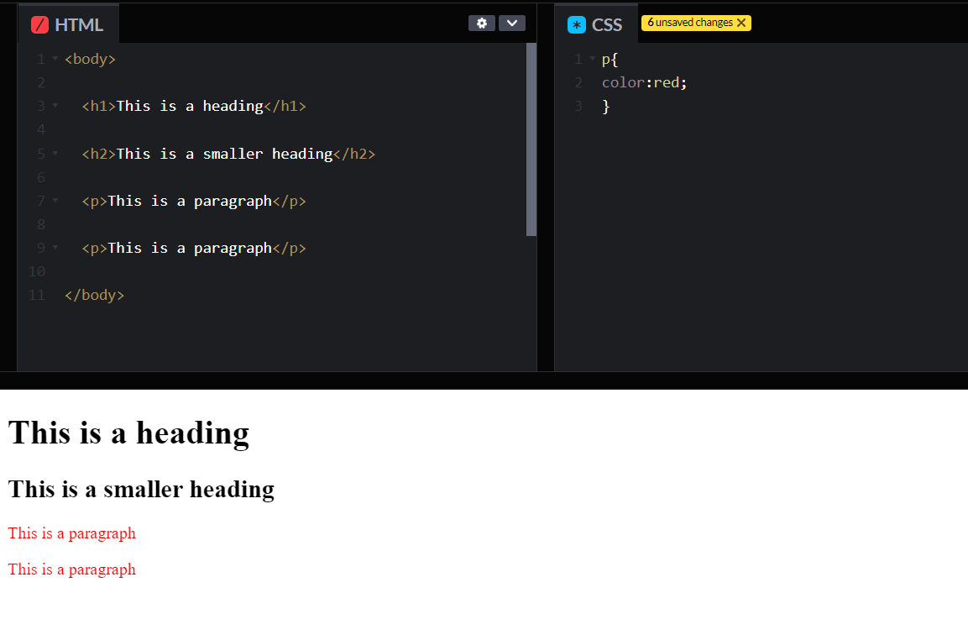

1. Set the color of the element with id="para1", to red.

<body>

<h1>This is a heading</h1>

<p id="para1">This is a paragraph</p>

</body>

1. Set the color of all elements with the class colortext, to red.

<body>

<h1>This is a heading</h1>

<p>This is a paragraph</p>

<p class="colortext">This is a paragraph</p>

<p class="colortext">This is a paragraph</p>

</body>

1. Change the color of all <p> and <h1> elements, to "red". Group the selectors to minimize code.

<body>

<h1>This is a heading</h1>

<h2>This is a smaller heading</h2>

<p>This is a paragraph</p>

<p>This is a paragraph</p>

</body>

1. Add an external style sheet with the URL: "mystyle.css".

<head>

<link rel = “stylesheet” href = “style.css”>

</head>

<body>

<h1>This is a heading</h1>

<p>This is a paragraph</p>

</body>

1. Set the page's background color to red.

<body>

<h1>This is a heading</h1>

<p>This is a paragraph</p>

<p>This is a paragraph</p>

</body>

1. Set the page's background color to red, by using an inline style.

<body style="_______________: ____">

<h1>This is a heading</h1>

<p>This is a paragraph</p>

<p>This is a paragraph</p>

</body>

1. Set the background color of the <h1> element to "lightblue".
2. Set "paper.gif" from local folder as the background image of the page.
3. Set an image from web as the background image of the page.
4. Specify that the background image should be shown once, in the top right corner.

<body>

<h1>This is a heading</h1>

<p>This is a paragraph</p>

<p>This is a paragraph</p>

</body>

1. Use the border property to set a "4px", "dotted", "red" border for the <p> elements.
2. Use the correct border property to set the LEFT border to "dotted".
3. Use the correct border property to add ROUNDED borders to the <p> elements.

<body>

<h1>This is a heading</h1>

<p>This is a paragraph</p>

<p>This is a paragraph</p>

</body>

1. Add 20 pixels left margin to the <h1> element.
2. Use the margin property to add 20 pixels top and bottom margins, and 40 pixels left and right margins, on the <h1> element.
3. For the <h1> element, use the shorthand margin property to add these margins:

left: 10px

right: 15px

top: 20px

bottom: 25px

1. Use the margin property to center align the <h1> element.

<body>

<h1>This is a heading</h1>

<p>This is a paragraph</p>

<p>This is a paragraph</p>

</body>

1. Set the top padding of the <h1> element to 30 pixels.
2. Set the padding of all sides of the <h1> element to 30 pixels.
3. Use the shorthand padding property to add 10 pixels left and right padding, and 40 pixels top and bottom padding, on the <h1> element.

<body>

<h1>This is a heading</h1>

<p>This is a paragraph</p>

<p>This is a paragraph</p>

</body>

1. Set the height of the <h1> element to "100px".
2. Set the width of the <h1> element to "50%".

<body>

<h1>This is a heading</h1>

<p>This is a paragraph</p>

<p>This is a paragraph</p>

</body>

1. Set the width of the <div> element to "200px".
2. Add a 2px solid red border to the <div> element.
3. Add 25 pixels space between the <div> element's border and it's content.
4. Add a 25 pixels space outside, to the left of the <div> element.

<body>

<div>

Lorem ipsum dolor sit amet,

consectetur adipiscing elit,

sed do eiusmod tempor incididunt

ut labore et dolore magna aliqua.

</div>

</body>

1. Set a solid, 5px outline border for the <div> element.
2. Set the color of the outline border to red.
3. Use the outline shorthand property to set a "4px", "dotted", "red" outline border for the <div> element.

<body>

<div>

Lorem ipsum dolor sit amet,

consectetur adipiscing elit,

sed do eiusmod tempor incididunt

ut labore et dolore magna aliqua.

</div>

</body>

1. Change the text color of all <p> elements to "red".
2. Center align the <p> elements.
3. Remove the underline from the link.
4. Style text in <h1> to uppercase letters, and text in <p> to capitalized letters.
5. Indent the first line of the <p> element with 20px.

<body>

<h1>This is a heading</h1>

<p>This is a paragraph</p>

<p>This is a paragraph</p>

</body>